Unit Learning Design Step 1:
  - Using the Unit Concept and Assessment Details Template
Introducing the template  The Unit Concept and Assessment Details template is intended to enable unit designers to present the core elements of a new/proposed unit with an emphasis on the assessment design.  A unit concept and assessment design is normally completed prior to representing the broader design for learning using the unit sequence template (step two). The Unit Sequence Template is available at: http://bit.ly/2savgCI  A unit concept and assessment design is intended to be read in conjunction with a unit sequence to inform the review of a proposed or existing unit of study.  The guidance in this document specifically refers to terminology and processes used at the University of Tasmania for units of study. | Before use  This unit concept and assessment details template is designed to be edited using Microsoft Word.  Many of the row and column headings within the tables below are accompanied by help text which can be viewed by hovering the mouse over the text.

GUIDANCE PART ONE – Unit Information
This component of the template is designed to document basic information which is commonly used to characterise a unit of study.
Field  Each column or row heading for which guidance is provided | Quick help  The instructional text visible upon rolling over corresponding item in the table above. | Additional information about providing this content  This information provides… | Technical tips  Guidance specific to modifying this document using Microsoft Word
Unit Title  Back to unit information table | Enter the current or proposed unit title | For pre-existing units, enter the current title. For a unit being conceptualised, enter a proposed title which captures/represents one or more of the following:  - The overarching problem or wicked problem necessitating the development of the unit  - The penultimate product or performance which students will produce in the unit  - The main conceptual domain students will learn about, in parallel with an active verb which may:  - differentiate the unit from any other units with a similar conceptual domain  - indicate the broad level of cognitive complexity | No complex editing techniques required. Text should be typed into table cell provided.
Unit Code/Year level  Back to Unit Information table | If the unit code is not yet defined, enter the part that is known (e.g. for a proposed breadth unit this would be “XBR???”) | Unit codes are typically comprised of six characters (3 letters and 3 digits).  - The three letters commonly represent the study area (i.e. ENG – engineering).  - The first of the three digits represent the nominal year level of the unit.  - The second digit may be used to represent sub-disciplines or areas of specialisation.  - The final digit may be used to individually classify multiple units from the same sub-discipline or specialisation at the same nominal year level. | No complex editing techniques required. Text should be typed into table cell provided.
Lead College/School  Back to Unit Information table | Enter the name of the college / faculty which will initially consider this unit for approval via their learning and teaching committee. | Enter the name of the college or faculty which will initially consider this unit for approval via their learning and teaching committee. In addition, you may enter the School, Department or National Centre where the majority of academics teaching into the unit are organisationally situated.  In the case of breadth units, you will need to list the Cross Faculty and the individual College/Faculties listed as managing the unit. | No complex editing techniques required. Text should be typed into table cell provided.
Unit Coordinator  Back to Unit Information table | This person may also be referred to as the unit designer | If there is not a designated unit coordinator, enter the name of the individual/s who are leading the development of the unit. | No complex editing techniques required. Text should be typed into table cell provided.
Study Mode(s)  Back to Unit Information table | A unit can be offered via off-campus (distance) and/or, on-campus study modes | Indicate whether the unit is being offered to students via distance and/or on-campus study modes. Please note that the term ‘blended’ typically refers to a sequence of learning which features a combination of physical and virtual/online components. The detail of the ‘blend’ is best represented using the unit sequence template. | No complex editing techniques required. Text should be typed into table cell provided.
Campus  Back to Unit Information table | State the location of study if an On-Campus” mode is offered, otherwise record this as “n/a (Off-Campus only)” | If the unit is offered only by distance, there is no need to state the campus. | No complex editing techniques required. Text should be typed into table cell provided.
Teaching pattern  Back to Unit Information table | For example: Lectures and Tutorials scheduled weekly across a 13 week period | It has been common practice to define the teaching pattern based on traditional patterns such as ‘A weekly lecture and tutorial over a 13 week teaching period’. With blended approaches to unit design, the teaching pattern may not be constant throughout the teaching period, nor may it be characterised by physical locations. Consequently, this field is an opportunity to briefly articulate the major components of the unit delivery using categories such as ‘instruction’ and ‘learning activities’. | No complex editing techniques required. Text should be typed into table cell provided.
Pre-requisites  Back to Unit Information table | Any unit which needs to be completed prior to undertaking the unit that you are designing or reviewing | Outline any units or subjects which must be successfully completed prior to undertaking this unit of study. | No complex editing techniques required. Text should be typed into table cell provided.
Co-requisites  Back to Unit Information table | A unit that needs to be undertaken in parallel with the unit that you are designing or reviewing | Please list any existing units that need to be studied concurrently with the unit you are designing.  For an existing course, you may be able to access the course documentation and handbook information. It is recommended that you consult the course coordinator/designer for guidance/clarification. | No complex editing techniques required. Text should be typed into table cell provided.
Mutual exclusion  Back to Unit Information table | A unit that cannot be counted for credit when the student has completed this unit that you are designing or reviewing | A common reason for two units being mutually exclusive within a qualification is that they are deemed to assess incredibly similar knowledge and skills. Considering the course(s) that this unit is unit is being designed for, are there any existing units that a student will not be allowed to undertake (or receive credit) after completing this unit?  For an existing course, you may be able to access the course documentation and handbook information. It is recommended that you consult the course coordinator/designer for guidance/clarification. | No complex editing techniques required. Text should be typed into table cell provided.
Replaces unit(s)  Back to Unit Information table | List any units this particular unit is intended to replace | List any existing units of study that this current unit is intended to replace. | No complex editing techniques required. Text should be typed into table cell provided.
Unit Weighting  Back to Unit Information table | Specify the % weighting of the unit in relation to an equivalent full time study period. The most common measurement at UTAS is 12.5% as one of eight units. | UTAS currently defines credit points per unit via a percentage point weighting. Working on the understanding that a full year of study is 100% weight, individual units are commonly weighted as 12.5% (as one of eight units).  One means of determining the appropriate unit weighting is to measure the intended volume of student learning. The Australian Qualifications Framework states that an annual full time student load should be nominally no more than 1200 hours. Consequently, a 12.5% unit equates to a maximum of 150 hours of student learning. To make a determination of student volume of learning, you can use the Calculating Student Volume of Learning template in conjunction with a draft learning design. | No complex editing techniques required. Text should be typed into table cell provided.
Professional Accreditation  Back to Unit Information table | Type “none” or state the related professional body | Many qualifications (or majors within qualifications) are professionally accredited. Professional accreditation bodies typically have a set of standards which they use as a means to evaluate the quality of the course. In relation to course and unit curriculum, these bodies facilitate a cyclical re-accreditation process where they evaluate the capacity of the course to produce graduates who possess the necessary skills and knowledge to commence employment as professionals (within a given vocation).  If you are unsure if the unit is contributing to a course which is professionally accredited, contact the relevant course coordinator.  Many of the professional accrediting bodies are listed on the TEQSA - Engagement with professional bodies website. teqsa.gov.au/regulatory-approach/engagement-with-professional-bodies | No complex editing techniques required. Text should be typed into table cell provided.
Teaching Team  Back to Unit Information table | List any academics (beyond the co-ordinator) who will co-develop the unit and/or have been designated to teach into the unit. | The group of individuals, other than the unit coordinator who are playing a role in the design and/or delivery of the unit. | No complex editing techniques required. Text should be typed into table cell provided.
Unit Description  Back to Unit Information table | Outline the key knowledge and skills that students will be expected to acquire; the evolution of topics contained in the unit delivery schedule; the main types of learning experiences; and how the unit prepares students for subsequent study/vocation | The unit description typically provides a succinct overview of the purpose, learning aims and sequence of intended learning in a unit of study. When writing a unit description for award units which function as a core element within a qualification and/or major/specialisation sequence, you will need to reference a set of intended learning outcomes.  A simple way to compose the unit description is to provide 1-2 line responses to each of the following dot points and then compile these responses into a single paragraph.  - Outline the key knowledge and skills that students will be expected to acquire  - Briefly articulating the evolution of topics contained in the unit delivery schedule  - Outline the main types of learning experiences that have been incorporated into the unit  - Describe how the unit prepares students for subsequent study and/or a vocational outcome | No complex editing techniques required. Text should be typed into table cell provided.

GUIDANCE PART TWO – Unit relationship to course
Field  Each column or row heading for which guidance is provided | Quick help  The instructional text visible upon rolling over corresponding item in the table above. | Additional information about providing this content  This information provides… | Technical tips  Guidance specific to modifying this document using Microsoft Word
Relevant Course(s)  Back to Unit Relationship table | List the course (code and title) that this unit is assessed within. | If this unit is assessed in more than one course, initially specify the course you will be demonstrating alignment to. | No complex editing techniques required. Text should be typed into table cell provided.
Relevant Course Learning Outcome(s)  Back to Unit Relationship table | List the Course Learning Outcomes which this unit is being designed to assess or directly prepare students for eventual assessment. | This component of the template is designed to document the role of the unit within a qualification. It is specifically intended for units which have been designed for a single qualification.  Please note: For units which have been designed for use in multiple courses, it will not be feasible to document course learning outcomes. In such cases, only document the intended learning outcomes for the qualification which is being reviewed or submitted for approval.  State which course learning outcome(s) (graduate level) the unit is being designed to assess. This would typically apply to a unit in the final stage of a qualification.  If the unit is situated in the early to mid-stages of a qualification, it is likely that it is not directly assessing the course learning outcome. In these instances, list the course learning outcomes which the unit is being designed to prepare students for eventual assessment.  The qualification or major may have been designed/documented using the conceptualising a new qualification process. If so, you would be able to access the reverse-chronological sequence of unit level intended learning outcomes. This sequence shows how a student will need to achieve progressively more complex intended learning outcomes before being in a position where he/she can achieve the respective course learning outcome. Each of the intended learning outcomes for this unit should be situated in one of more (ideally no more than two) of these sequences. | Text should be typed into the table cells provided to replace the placeholder text.  How to add CLOs:  The Unit Relationship table is actually a set of tables within tables. If you need to indicate alignment to more than one CLO, the best way is to duplicate the whole set including the header row.  Tip: clicking the [+] icon to the top left of each table selects all the cells and the contents:  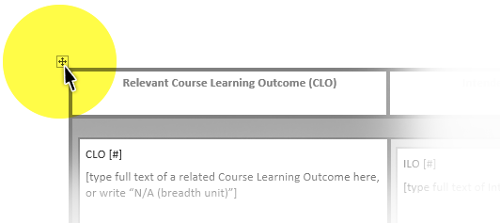  If you would like more detailed instructions, you can watch Adding a CLO (video).
Intended Learning Outcomes (ILOs)  Back to Unit Relationship table | Draft a series of intended learning outcomes which need to be achieved in order for a student to pass the unit. | Intended learning outcomes (ILOs) are statements that outline the knowledge and/or skills that students are required to demonstrate in order to successfully complete the unit of study.  For an award unit  The composition of an ILO needs to be informed by the respective course learning outcomes that they have been intended to assess (or prepare students for eventual assessment). For this reason it is ideal that the intended learning outcome or a declaration of required knowledge and skills has been created at the time of conceptualising the course or major/minor/specialisation. In this ideal scenario, each course learning outcome (CLO) sits at the top of a list featuring a reverse chronological sequence of intended learning outcomes or strings containing ‘threshold skills’ + ‘threshold knowledge’ + ‘desirable context’ + ‘necessary enablers’. This process is demonstrated in the ‘Expanding Course Learning Outcomes’ section of Conceptualising a new qualification  This list of ILOs/threshold knowledge and skills resembles a ladder, where the CLO sits at the top and each ILO / string is a new rung on the ladder. As students achieve each ILO on a rung they progressively work toward achieving the stated CLO. Without access to a hierarchy of ILOs or threshold knowledge/skills underpinning each CLO, it can be difficult to determine how an ILO for a second year unit in a three or four year degree prepares students to inevitably achieve a CLO.  For units in qualifications which are professionally accredited  If the qualification is professionally accredited there will be professional standards or competencies which need to be assessed. You will need to reference your course documentation to see whether the unit has been designated to assess a particular selection of professional standards. Each intended learning outcome should be composed using both the stated CLO and professional competency/standard(s) as primary reference points. It is possible that a single intended learning outcome is assessing more than one professional competency/standard. There is capacity to enter multiple professional competencies/standards in horizontal alignment with each intended learning outcome. Simply add a new row for each professional competency/standard that is being assessed by the respective intended learning outcome.  As with a typical award unit, it is ideal that the intended learning outcome or a declaration of required knowledge and skills has been created at the time of conceptualising the course or major/minor/specialisation. In this ideal scenario, each course learning outcome (CLO) sits at the top of a list featuring a reverse chronological sequence of intended learning outcomes or strings containing ‘threshold skills’ + ‘threshold knowledge’ + ‘desirable context’ + ‘necessary enablers’. The composition of each ILO or string should correspond with a competency/standard. This process is demonstrated in the ‘Expanding Course Learning Outcomes’ section of Conceptualising a new qualification.  The list of ILOs/threshold knowledge and skills + competencies/standards resembles a ladder, where the CLO sits at the top and each ILO / string is a new rung on the ladder. As students achieve each ILO (and professional competency) on a rung they progressively work toward achieving the stated CLO. Without access to a hierarchy of ILOs or threshold knowledge/skills underpinning each CLO, it can be difficult to determine how an ILO for a second year unit in a three or four year degree prepares students to inevitably achieve a CLO.  Composing an Intended Learning Outcome  An intended learning outcome is typically written using a fixed structure. Please see Intended Learning Outcomes - a quick guide for a succinct guide to composing ILOs using a fixed structure. The finalised set of ILOs should serve as your primary reference point for designing assessment tasks. Each assessment task will need to measure a student’s performance in relation to one or more ILOs. For a 12.5% unit aim to not compose a maximum of 5 ILOs (ideally 3). | Text should be typed into the table cells provided to replace the placeholder text.  How to add ILOs:  If you need to indicate alignment to more than three ILOs per CLO, you will need to add rows to the ILOs table. To do this, you can right-click in any ILO cell and from the drop-down menu select Insert > Insert rows below.  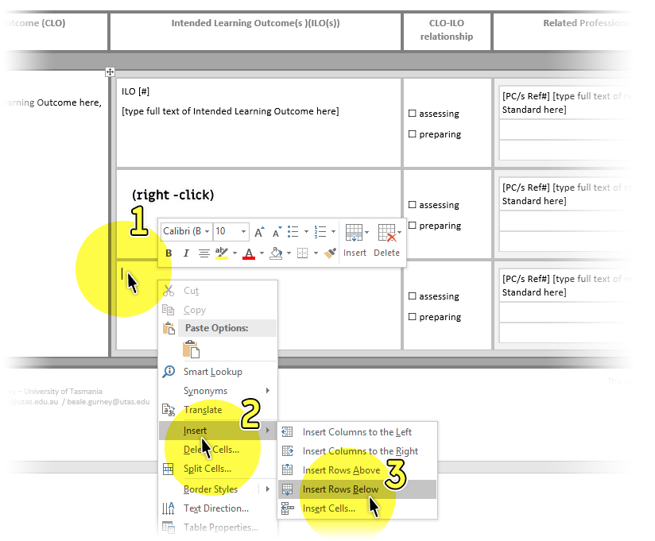  How to remove ILOs:  It is likely that you will not need all the rows provided. You can either leave unnecessary ones blank, or delete them by right-clicking in any unnecessary row, selecting Delete cells from the drop down menu, then choosing Delete entire row from the pop up options.  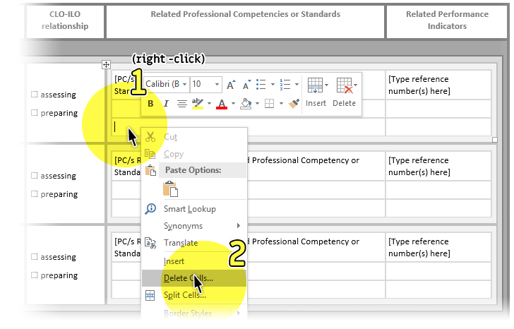
CLO-ILO relationship  Back to Unit Relationship table | Indicate whether each CLO is being assessed via the ILO, or whether it is preparing students to achieve the ILO later in the course. | Most qualifications contain a series of Course Learning Outcomes (CLOs) which define the required application of knowledge and skills for graduates. Each unit of study within the qualification will comprise a series of Intended Learning Outcomes which define the application of underpinning or threshold knowledge and skills related to one or more CLOs. As the CLOs define the graduate, a student is unlikely to be achieving a CLO via set of ILOs for a second unit in a four year honours degree. In such cases, the ILOs are likely to be preparing students for eventual achievement of a CLO. | Click on the corresponding checkbox for each item. A tick will appear.  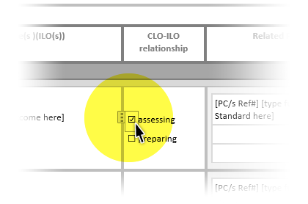
Related Professional Competencies or Standards  Back to Unit Relationship table | For each ILO - list any professional competencies that will be achieved when the student has achieved the related ILO. | This section is only relevant if this unit is being assessed as part of a professionally accredited qualification. Nominate which competencies or standards are being assessed via each of the intended learning outcomes (ILOs). In effect, you are declaring which professional competencies a student is achieving, when they achieve the intended learning outcome positioned on the same row. | Text should be typed into table cell provided.  How to add Professional competencies or standards:  If you need to indicate relevance to more than three professional competencies per ILO, you will need to add rows to the Professional competencies and professional standards table. To do this, you can right-click in any ILO cell and from the drop-down menu select Insert > Insert rows below.  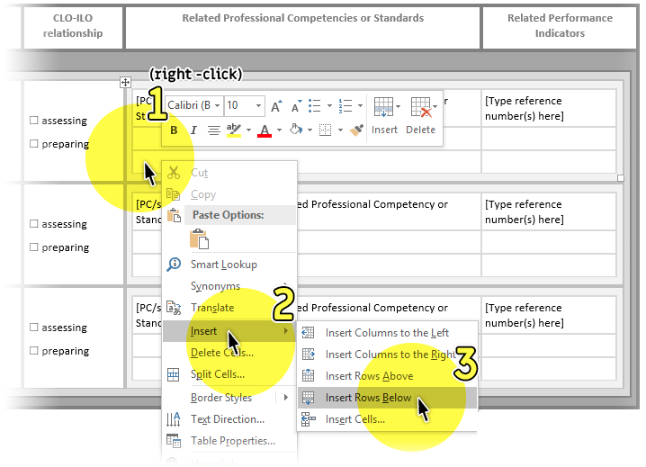  How to remove professional competencies or standards:  It is likely that you will not need all the rows provided. You can either leave unnecessary ones blank, or delete them by right-clicking in any unnecessary row, selecting Delete cells from the drop down menu, then choosing Delete entire row from the pop up options.  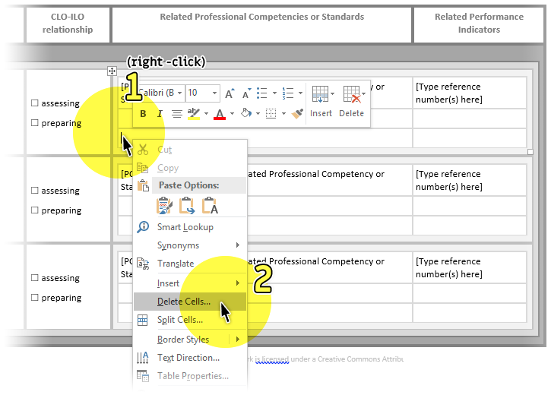
Related Performance Indicators  Back to Unit Relationship table | If the particular competency has associated performance indicators or criteria – list the numeric reference (e.g. 2.9) at minimum. | Some professional accrediting bodies have defined a set of performance indicators for each competency or standard. These performance indicators are generally intended to assist the re-accrediting panel to determine whether the standard/competency is being assessed in multiple pre-defined contexts across the qualification. For each stated standard/competency, specify which performance indicators are being addressed. You may not be able to finalise this field until after you have designed the schedule of individual assessment tasks. | Text should be typed into table cell provided.  How to add Related performance indicators:  See instructions above, for adding rows to the Related performance indicators table.  How to remove Related performance indicators:  See instructions above, for removing rows from the Related performance indicators table.
Graduate Qualities  to be Assessed  Back to Graduate Qualities table | Indicate which themes and skills from the UTAS graduate statement are being assessed in this unit design | You can demonstrate that you are assessing a graduate theme and/or skill via the intended learning outcomes, assessment methods and/or assessment criteria. Please see Assessing the graduate statement for examples and guiding notes, explaining how each of these unit elements can be used to assess the graduate qualities.  Given that you will design and document individual assessment tasks later in the template, it is highly likely that you may come back to this section repeated times prior to submitting a draft unit concept. | No complex editing techniques required. Text should be typed into table cell provided.

GUIDANCE PART THREE - Assessment Tasks
The third component of this template is intended for the design of an assessment schedule for a unit of study.
Assessment tasks primarily provide students with opportunities to demonstrate achievement of the Intended Learning Outcomes. Only document those formal assessment tasks which directly assess intended learning outcomes and are mandatory for successful completion of the unit.
The format of the table for designing assessment tasks enables you to show how each assessment task specially assesses one or more intended learning outcomes. For new units it is preferable to design one assessment task per intended learning outcome as this clear alignment will make the task of formulating assessment criteria far easier.
Field  Each column or row heading for which guidance is provided | Quick help  The instructional text visible upon rolling over corresponding item in the table above. | Additional information about providing this content  This information provides… | Technical tips  Guidance specific to modifying this document using Microsoft Word
Key Details  Back to Assessment section | Quick help text is available for each of the headings below | N/A (guidance is provided for each subheading below) | N/A (guidance is provided for each subheading below)
Task Title  Back to Assessment section | Try and write a title which refers to the area of enquiry and/or action the students will perform. Try and avoid using the assessment method as the title. | A statement which captures/represents the overarching problem or outcome necessitating the development of the assessment task. Avoid referring to the assessment task via the assessment method (i.e. essay). | No complex editing techniques required. Text should be typed into table cell provided.
Method  Back to Assessment section | See page 99 of 'Assessing and assuring Australian graduate learning outcomes: principles and practices within and across disciplines' for an extensive list of common methods | There are various considerations that you will need to make in terms of selecting or devising an appropriate assessment method:  - Active verb – The active verb for the ILO will articulate the type of cognition that students will need to demonstrate (e.g. explain, classify etc.). You will need to select a method which feasibly enables a student to demonstrate this form of cognition.  The TALOE Webtool enables you to enter your ILO and be presented with common assessment task methods which correspond with the respective active verb in the ILO.  - Focus and Condition – The focus and condition of the ILO will serve as a useful point to:  - Select potential methods from a glossary, such as P.99 of Assessing and Assuring Australian Graduate Learning Outcomes  - Exclude any assessment methods you may have already considered.  - Graduate statement – In relation to any assessment methods you have nominated, is there capacity to assess any particular skills from the graduate statement? Please see Assessing the graduate statement and explicitly look at the skills and consider how these could be assessed within any of the methods you have nominated.  - Authenticity - In relation to the knowledge and skills you are assessing in this task, does the intended assessment method reflect their use in a vocational context?  - Diversity – Does your intended assessment method differ to those intended/selected for the other assessment tasks in the unit of study? | No complex editing techniques required. Text should be typed into table cell provided.
Weighting %  Back to Assessment section | How much does the assessment result from this task contribute to a student's final result for the unit? | The weighting of an assessment task is a percentage based representation of the proportion of assessment across the entire unit. In order to determine an appropriate weighting, consider how long it would nominally take a student to prepare for and perform this assessment task.  One means of determining the appropriate assessment task weighting is to determine how long each assessment task should nominally take a student to directly prepare for and complete. The weighting should reflect the proportion of student volume (hours) which you have associated against one task in relation to overall schedule of assessment.  For example, in a 12.5% weighted unit with a maximum of 150 hours of student learning, formal assessment may constitute 50% of this overall volume (approx. 75 hours). One assessment task (out of three) which has been assigned a nominal hours figure of 15, would roughly equate to an assessment weighting of 20%. To make a determination of student volume of learning, you can use the Calculating Student Volume of Learning template in conjunction with a draft learning design. | No complex editing techniques required. Text should be typed into table cell provided.
Size/length  Back to Assessment section | This will vary depending on the choice of assessment method - i.e. Essay - 3000 words. Consider whether this condition reflects the assessment weighting given to the task and the norms for the AQF level | The purpose of this field is to state what the maximum (and minimum) size, duration or length of the assessment task. Most assessment tasks can be bluntly categorised into three categories of performance (duration), product (size) and written (length). In some portfolio based assessment tasks it may be necessary to utilise a combination of measurements. | No complex editing techniques required. Text should be typed into table cell provided.
Due  Back to Assessment section | Indicate when the assessment task will be due in relation to the duration of the teaching period (for e.g. week 3) | Indicate when students are due to submit this piece of assessment in relation to the overall duration of the teaching period. For example, in a 13 week semester the task may be due in week 3. In an intensively facilitated unit, you may opt to use a statement such as End of Day 2 of 10. You may need to revise these dates after you develop the learning design sequence which encompasses the learning activities, feedback and instruction. | No complex editing techniques required. Text should be typed into table cell provided.
Graduate Statement  Back to Assessment section | List the themes and or skills from the UTAS graduate statement that are being assessed in this task. | You can demonstrate that you are assessing a graduate theme and/or skill via the intended learning outcomes, assessment methods and/or assessment criteria. Please see Assessing the graduate statement for examples and guiding notes, explaining how each of these unit elements can be used to assess the graduate qualities. | No complex editing techniques required. Text should be typed into table cell provided.
Assessed Professional Competencies & Standards  Back to Assessment section | If professionally accredited - indicate which competencies or standards are being assessed in this task using their numerical reference (e.g. 3.1) | This section is only relevant if this unit is being assessed as part of a professionally accredited qualification, Earlier in the template you would have nominated which competencies or standards are being assessed via each of the intended learning outcomes (ILOs). The assessment task should be assessing all the competencies/standards which horizontally aligned with any of the ILOs you are assessing in the task. This is one of the reasons why you should try and keep the number of ILOs you are assessing per assessment task to a minimum. | No complex editing techniques required. Text should be typed into table cell provided.
Task Description  Back to Assessment section | A concise outline of the task with emphasis on what will students be required to do. | Write a concise outline of the task with emphasis on what will students be required to do. In addition, you may briefly outline any conditions which are inherent to the task. If the task is an assemblage of small tasks, you will need to dot point each component.  You will need to provide a more detailed description of the assessment task to the students via the unit outline. In this document you will have the opportunity to provide a detailed rationale, overview, instructions, conditions and definition of academic involvement. | No complex editing techniques required. Text should be typed into table cell provided.
ILOs Assessed  Back to Assessment section | Nominate which intended learning outcomes are being assessed in this task. | Ideally try and design your tasks based on a single intended learning outcome as this will enable you to easily demonstrate how your assessment criteria are directly assessing a student’s achievement of an intended learning outcome. | No complex editing techniques required. Text should be typed into table cell provided.
Assessment Criteria  Back to Assessment section | Write at least one assessment criterion for each ILO that is being assessed in the task. | Assessment criteria are a set of key components and characteristics of an assessment task which enable you to determine that the student has demonstrated achievement of the intended learning outcome.  These are typically developed at one of two stages:  - Post ILOs – Once you have drafted a set of intended learning outcomes, it is possible to draft a sequence of characteristics which students will need to demonstrate. These criteria will then be used to inform the selection of an assessment method.  - Post Assessment Method – An ILO’s focus and condition may specify (or severely narrow the scope) the method of assessment.  Think of the assessment criteria as umbrellas or categories. Assessment criteria normally don’t feature a qualifier (i.e. excellent, detailed) or a quantifier (i.e. five, multiple), as these are included in performance standards. Performance standards are statements which enable you to determine the level of achievement for each criterion. These are composed when you develop a rubric, post completion of this template. | No complex editing techniques required. Text should be typed into table cell provided.

